

ENABLING SERVICES INTELLIGENCE · WESTERN PROVINCE
WPGIS TRAINING
WORKPACK
Facilitator guide · participant manual · operating reference
7  application areas | 4  role pathways | 5  practice scenarios | 3.5 h  facilitated session

Version 1.0 · 23 August 2026
Purpose Build confident, consistent and evidence-aware use of wpgis.org across leadership, delivery, operations, finance and administration.

Prepared for PNG Sustainable Development Program Limited
Developer: Christopher Odorry · Enabling Services · christopher.odorry@pngsdp.org

DOCUMENT CONTROL

How to use this workpack
Use this resource in a facilitated session, as an induction pack, or as a desk reference. The screenshots represent the application as at 23 August 2026; governed data and interface details may evolve.
ROLE | PRIMARY PURPOSE | TYPICAL ACCESS | ACCOUNTABILITY
Document owner | Enabling Services | WPGIS training and controlled operating guidance | Maintain approved version and change log
Facilitator | Appointed trainer | Entire pack and presentation | Demonstrate using approved examples only
Participant | Authorised PNGSDP user | Modules applicable to their role | Apply evidence and privacy controls
Technical support | Designated WPGIS administrator | Access, defects, governed updates | Resolve or escalate without bypassing controls

Document control
Version  1.0 · initial consolidated training release | Classification  Internal training material · access-controlled application
Source basis  wpgis.org production application and governed local source package | Review trigger  Material workflow, access, data model or visual change
Privacy scope  No personal, payroll, banking, medical or property information is required | Authority boundary  Training does not replace policies, delegated authority or source-system ownership

Learning outcomes
- Access WPGIS securely with the approved PNGSDP email and one-time PIN.
- Select the correct module and use filters before interpreting totals or map features.
- Ask Sibala Dalagi evidence-grounded questions and identify source and limitation statements.
- Maintain asset, project and finance workflows without breaking audit or approval controls.
- Produce decision-ready A4 briefs while protecting governed and sensitive information.

APPLICATION ORIENTATION

WPGIS at a glance
WPGIS is a connected decision-support environment. The browser interface displays governed GIS, population, maintenance, programme and finance working data; it does not replace the separately controlled source files.
01 | Access Atlas  Explore mapped people, communities, services, assets and planning layers.
02 | Intelligence Hub  Interpret coverage, evidence readiness, gaps, scenarios and portfolio context.
03 | Maintenance Command  Monitor airstrips, water landing sites, borewells and towers by status and evidence.
04 | Programme Delivery Office  Create, plan, review, approve and monitor programmes, projects and tasking.
05 | Finance Workflow  Prepare, route, approve and export payment request forms with metadata controls.
06 | Administration  Authorised changes to working records, with user identity and audit history.
07 | Training Centre  Role pathways, manual, presentation, exercises and quick-start reference.

What it is not A navigation system, a replacement for field verification, a source of inferred missing values, a repository for personal data, or a substitute for financial and operational delegations.

OPERATING METHOD

Decision chain
01 | Scope  Select the district, LLG, programme, asset class, status or date range.
02 | Read  Review the value, source, evidence date, mapped/unmapped flag and limitation.
03 | Interpret  Use the dashboard or Sibala to describe the evidence without overstating certainty.
04 | Act  Record the approved task, update, review, decision or escalation in the correct workflow.
05 | Assure  Confirm the audit trail, evidence reference and required approval before reporting completion.

SECURE ACCESS

Sign in and protect the session
Cloudflare Access presents the branded WPGIS login. Authorised users enter their PNGSDP email address, receive a one-time PIN and use it to open the protected application.
01 | Open the site  Go to https://wpgis.org using a current browser.
02 | Enter the authorised email  Use your @pngsdp.org address. Do not use a shared or personal mailbox.
03 | Retrieve the one-time PIN  Check the email, confirm the site name and use the current PIN only.
04 | Complete sign-in  Enter the PIN in the Cloudflare Access window. Access is limited by the configured session duration.
05 | Close securely  Sign out or close the browser when using a shared device. Never forward the PIN.

Administrator access The general PNGSDP email policy does not grant administrator rights. Restricted administration paths are governed by a separate policy for the designated administrator account.

Access troubleshooting
PIN did not arrive  Confirm spelling, inbox rules, junk folder and that the mailbox can receive external service messages. | Login loop  Use a private/incognito window, confirm the intended email and retry once. Do not repeatedly request PINs.
Access denied  The module may require a narrower role or administrator policy. Record the URL and contact support. | Expired session  Return to wpgis.org and complete a fresh one-time PIN sign-in.

COMMON CONTROLS

Navigate, filter and report consistently
All modules use the same operating logic: choose a scope, read the status, inspect evidence, then act through the appropriate workflow.
Navigation rail  Moves between dashboard areas. Restricted links still require the correct Access policy. | Filters  Narrow totals by district, LLG, programme, asset type, status, date or search phrase.
KPI cards  Show the current filtered scope. They are not separate totals and should be read with source notes. | Charts  Summarise composition, evidence completeness, location distribution or progress.
Tables  Provide record-level detail, action buttons and evidence fields. | Print / export  Creates a decision brief from the current view. Verify the scope before distribution.
Scope test Before quoting a number, say: ‘This figure represents [scope], from [source], as at [date], with [known limitation].’

MODULE 1 · ACCESS ATLAS

Explore people, places, services and infrastructure
The Access Atlas is the primary geographic interface. It opens at the Western Province extent with limited surrounding context and supports map layers, search, filters, hover summaries and detailed click records.
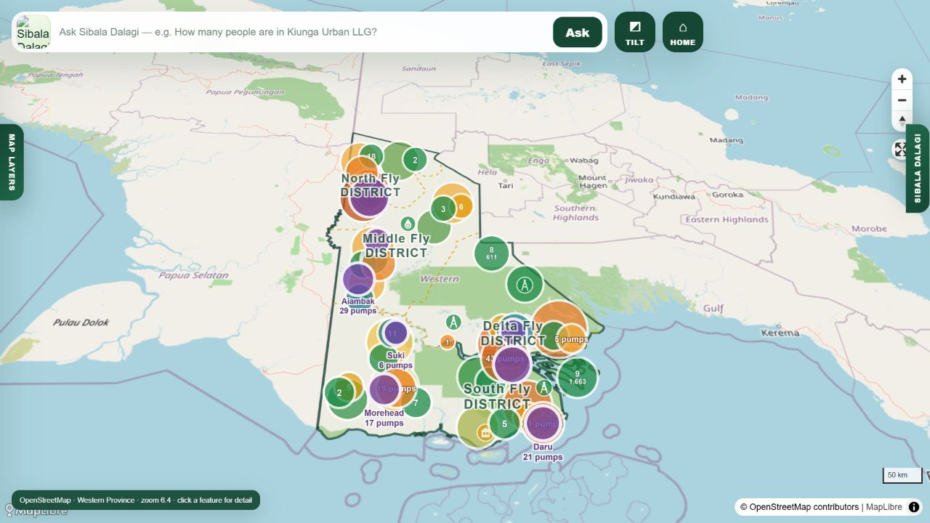
Access Atlas: province-wide planning view with clustered population and infrastructure symbols.
01 | Open Map Layers  Use the left MAP LAYERS indicator and pin the panel if working through multiple selections.
02 | Choose the administrative scope  Select All, district and LLG filters before reading statistics.
03 | Choose a layer  Open the relevant dropdown: communities, CMCA, facilities, telecommunications, water, transport or programme portfolio.
04 | Inspect progressively  Hover for a basic summary; click a feature for detailed governed attributes.
05 | Reset before a new question  Clear incompatible selections so a prior filter does not affect the next interpretation.

Map limitation Distances and 3 km access estimates are planning calculations. They are not verified travel time, road condition, boat schedule, service availability or navigation advice.

ACCESS ATLAS

Read layers and statistics
Layer statistics change with the current map and filter scope. Counts describe mapped records; they do not automatically prove that an asset exists, operates or serves the displayed population.
ROLE | PRIMARY PURPOSE | TYPICAL ACCESS | ACCOUNTABILITY
Administrative areas | District, LLG, ward and province boundaries | Orient the decision and control scope | Boundary/label source and scale
Communities | Mapped community points and aggregated population | Location and visible population analysis | 77,126 people remain outside mapped visibility
CMCA regions | Selectable regional shades and community sub-filter | Regional context and engagement planning | Historical map extraction requires validation
Water | Existing borewells, planned allocations and staging | Coverage and deployment planning | Allocation is not installed infrastructure
Transport | Airstrips, landing sites, ports and routes | Nearest mapped access and maintenance context | Operational status and routes need verification
Telecommunications | Confirmed operational and planned tower records | Connectivity planning | Planned sites must not be shown as operational

Population reading checklist
- Mapped population: people linked to a community geometry in the approved consolidated table.
- Unmapped population: source-table population without a reliable community pin; do not spatially allocate it by guess.
- Cluster total: aggregates records visible at the current zoom; click or zoom for the component detail.
- 3 km borewell access: straight-line planning estimate from mapped communities; not a household survey result.

MODULE 2 · SIBALA DALAGI

Ask evidence-grounded questions
Sibala Dalagi is the conversational Western Province GIS assistant. Local GIS calculations remain authoritative; the AI helps interpret the results in plain language and maintain conversational context.
Good question  How many functional borewells are mapped in [LLG], and what mapped population is within 3 km? | Good question  Which mapped airstrip or landing site is nearest to [community], and what is its recorded status?
Good question  Compare mapped population visibility between [district A] and [district B]. | Good question  Which maintenance records in [district] lack an inspection date or evidence reference?
Avoid  Is this route safe today? — requires current operational advice, weather and field verification. | Avoid  Tell me the missing coordinate. — the assistant must not invent absent geography.
01 | Name the place precisely  Include district or LLG where the same or similar name may occur more than once.
02 | Name the evidence class  Ask for borewells, airstrips, population, projects, maintenance or PRF metadata.
03 | Name the status or time  Specify functional/planned/WIP, inspection date, project phase or approval stage.
04 | Ask for limitation  Request the source, evidence date and what remains unverified.
05 | Verify on screen  Use the source chip, map popup or record table before acting on the response.

When AI is unavailable The governed application and local calculations continue to work. Use the map, dashboard and evidence library; report the error without copying sensitive content into a support message.

MODULE 3 · INTELLIGENCE HUB

Interpret evidence for leadership and delivery
The Intelligence Hub converts governed map and database records into a decision workspace for leadership, programme officers, field operations and consultants.
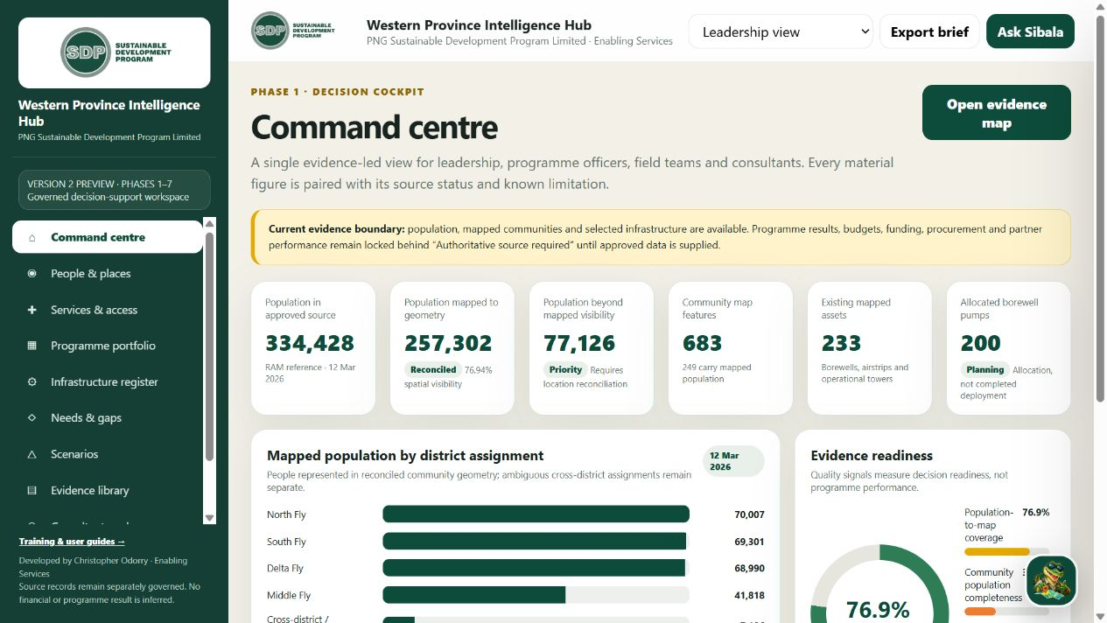
Intelligence Hub command centre: every material figure is paired with evidence status and known limitation.
ROLE | PRIMARY PURPOSE | TYPICAL ACCESS | ACCOUNTABILITY
Command centre | Executive evidence summary | Population visibility, mapped assets and readiness | Open evidence map or export brief
People & places | Geographic and population view | District/community visibility and uncertainty | Investigate gaps without forced allocation
Services & access | Infrastructure and access | Coverage, status and nearest mapped asset | Separate presence from functionality
Portfolio | Programme/project intelligence | Approved projects and location relationships | Source required for unapproved results
Evidence library | Source and limitation register | Authority, date and known caveats | Use before high-stakes reporting
Consultant workspace | Structured review support | Findings and evidence references | No inference of programme or financial outcome

Consultant rule A map feature is not proof of programme performance. Link every finding to the approved evidence source and state where data is incomplete.

MODULE 4 · MAINTENANCE COMMAND

Assure airstrips, borewells and towers
The Maintenance Command presents filtered operational assurance views for transport, water and telecommunications assets. It uses the governed working database and approved GIS layers.
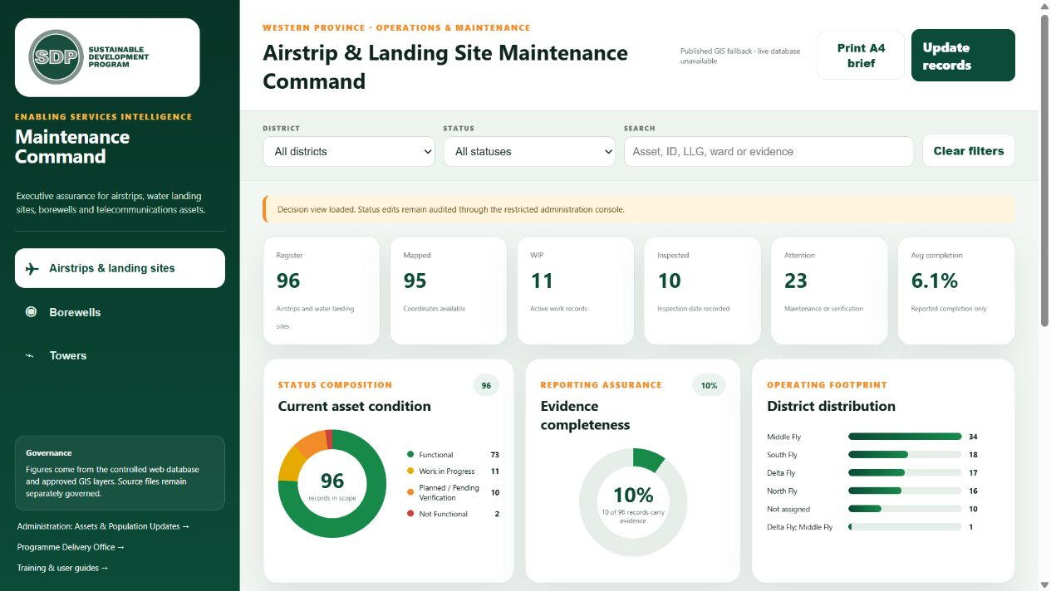
Airstrip and landing-site command view: status, evidence completeness, district distribution and management attention queue.
GREEN  Functional | YELLOW  Work in progress | ORANGE  Planned / verify | RED  Not functional

MAINTENANCE COMMAND

Operating sequence
01 | Choose the asset class  Airstrips & landing sites, Borewells, or Towers.
02 | Set the scope  Select district and status; use search for asset ID, LLG, ward or evidence.
03 | Read the assurance cards  Register, mapped, WIP, inspected, attention and completion values reflect the filtered scope.
04 | Review exceptions  Open the priority queue and confirm evidence, inspection date and current task.
05 | Update through Administration  Authorised users use Update Records; never overwrite source coordinates from the dashboard.
06 | Print the brief  Verify filters, generated timestamp and source note before distribution.

Status discipline Planned, pending verification and work in progress are not functional. A status change needs inspection or authorised evidence and remains auditable.

MODULE 5 · PROGRAMME DELIVERY OFFICE

Create, plan, review and monitor projects
Every new project receives a timestamp-based unique identifier. The owner prepares a dated plan of up to 20 segments, submits it to a manager and responds to review comments before CEO monitoring is activated.
01 | CEO / sponsor issues the brief  Enter the task intent, owner email, required dates and relevant programme/location context.
02 | Owner accepts and plans  Confirm start/end dates, create up to 20 sequenced plan segments and assign owners/evidence.
03 | Owner submits to manager  Enter the manager email and issue the complete plan for review.
04 | Manager reviews  Approve or return to originator with a clear change request. Iterations remain in the audit history.
05 | Register for monitoring  After approval, the project becomes available in the CEO portfolio when CEO monitoring was selected.
06 | Report progress  Update actual progress, dates, evidence and exceptions. Do not convert a blank value into an assumed result.

Mandatory project controls
Unique ID  Timestamp-based identifier; quote it in correspondence, evidence and related finance requests. | Dates  Project and every plan segment require start/end dates; milestones must sit within the approved envelope.
Ownership  Use work email addresses for owner and manager to preserve identity and workflow routing. | Change control  Record why scope, date, owner or outcome changed; never silently rewrite the baseline.
Evidence  Link deliverable progress to an approved reference, inspection, acceptance or source record. | CEO view  Shows approved portfolio progress, exceptions, legacy tasking and assurance—not unapproved drafts.

PROGRAMME DELIVERY OFFICE

Read the CEO & Chief Operations dashboard
The executive dashboard should answer: what is being delivered, who owns it, where it is, when it is due, what has changed and what requires intervention.
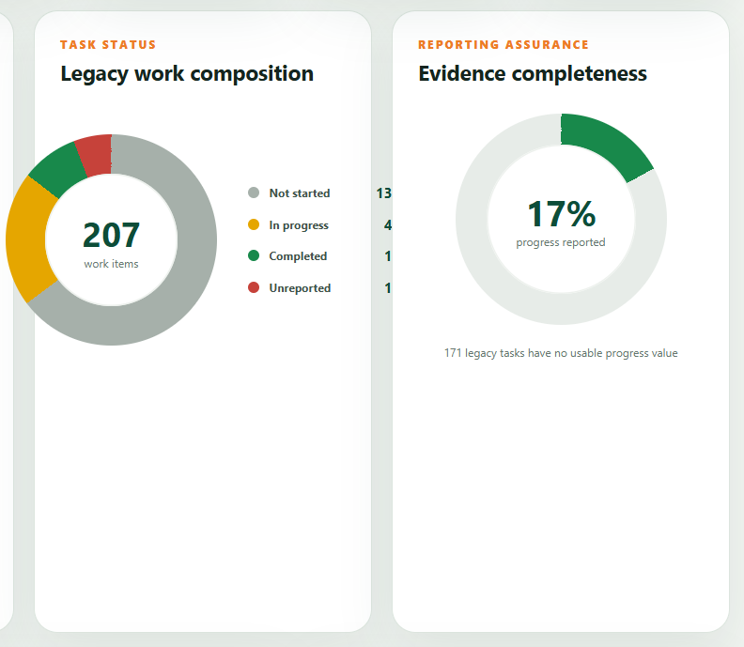
Example executive dashboard visuals: compact status composition and evidence-completeness graphics.
ROLE | PRIMARY PURPOSE | TYPICAL ACCESS | ACCOUNTABILITY
Portfolio total | Approved projects/tasks in current filters | Scale of active delivery portfolio | Check legacy inclusion and duplicate IDs
Schedule | On track, due, overdue and date exceptions | Timing intervention | Read baseline vs current dates
Progress | Completed, in progress, not started, unreported | Delivery status | Unreported is a control gap, not zero progress
Assurance | Evidence completeness and stale updates | Confidence in reporting | Ask owner for missing evidence
Geography | District, LLG, ward and community filters | Place-based coordination | Unpinned tasks remain non-spatial
Legacy tasking | Optional checkbox / filter | Compare inherited work with new workflow | Legacy records may lack modern fields

MODULE 6 · FINANCE WORKFLOW

Prepare and progress a payment request
The finance module enhances workflow and expenditure visibility while retaining only governed workflow, financial and file-verification metadata. Quotes and the generated PDF remain on the user’s device.
01 | Originator creates the PRF  Select programme, project ID, budget line, location and payment metadata. Do not enter bank account or personal information.
02 | Reference the project  Use the timestamp-based WPGIS project ID so the expenditure links to the approved delivery record.
03 | Attach locally / record metadata  Select quotes or supporting files. The application records verification metadata such as name and hash; file contents are not retained in D1.
04 | Route to reviewer  The reviewer checks completeness, eligibility, budget reference and evidence.
05 | Route to endorsement  The endorser confirms programme and operational justification.
06 | Final approval  The delegated approver approves or returns the request. All in-flight stages can return it to the originator with reasons.
07 | Export and send  Generate the PDF locally, inspect it and send the package to Finance using the approved corporate email process.

Control boundary The workflow supports visibility and traceability; it does not replace PNGSDP financial policy, budget control, procurement requirements, delegated authority or Finance review.

Expenditure map
- Only approved expenditure with a governed location is eligible for the spatial view.
- The heat map represents expenditure intensity, not project impact, asset performance or value for money.
- Use programme, project, budget line, district, status and date filters before comparing values.
- Unmapped expenditure must remain visible in non-spatial totals so it is not lost from reporting.

MODULE 7 · ADMINISTRATION

Maintain working records with an audit trail
Administration is separated from ordinary viewing. Access is restricted to the designated administrator policy; write operations capture the authenticated identity and append to the audit history.
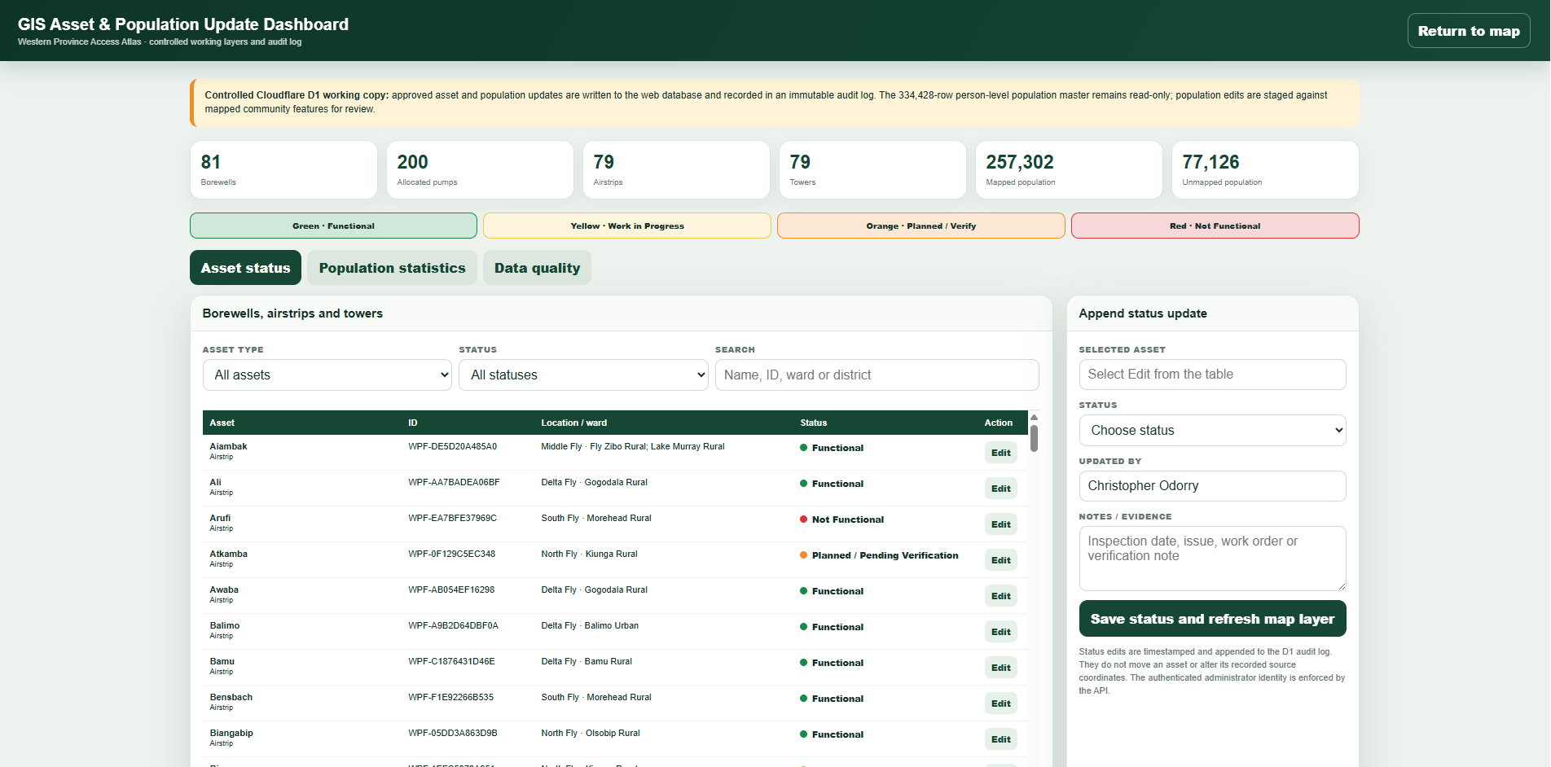
Controlled administration dashboard: asset status, population, data quality and usage assurance.
01 | Confirm authority and source  Do not update a record because a map ‘looks wrong’. Obtain the approved source or field evidence.
02 | Find the exact record  Search using stable asset ID, location, district/LLG/ward and record type.
03 | Review current values  Check status, previous notes, coordinates, evidence date and audit history.
04 | Append the update  Choose the traffic-light status, add evidence/inspection notes and save through the controlled endpoint.
05 | Validate downstream display  Refresh the relevant dashboard and map layer; confirm that counts and status composition reconcile.
06 | Retain source governance  The original Access database, ArcGIS files and approved source artefacts remain separately controlled.

Coordinate control The administration dashboard does not move a feature or silently alter source coordinates. Coordinate changes require the governed GIS reconciliation workflow and approval.

DATA GOVERNANCE

Protect evidence, privacy and trust
WPGIS is designed to visualise scattered operational data without turning the public-facing map into a repository of personal or property information.
ROLE | PRIMARY PURPOSE | TYPICAL ACCESS | ACCOUNTABILITY
Source truth | Access population database, ArcGIS layers, approved registers | Preserve original records and source dates | Data owner / approved custodian
Working copy | Cloudflare D1 and optimised web layers | Serve controlled operational views and updates | Authenticated workflow and audit
Display | HTML, CSS, JavaScript, MapLibre/OpenStreetMap | Visualise the governed working copy | No embedded API secret or source database
Interpretation | Sibala Dalagi / approved API backend | Explain governed evidence in context | No invented coordinate, status or result
File handling | Quote/supporting-document metadata | Trace file selection without storing contents | Generated PDF remains on device

Do not enter or upload
- Bank account numbers, payroll data, passwords, PINs, API keys or authentication tokens.
- Personal medical, disciplinary, beneficiary or household-identifying information.
- Property ownership records or sensitive landowner detail unless a separately approved system and policy exists.
- Unverified coordinates, rumours or planned assets represented as operational facts.
- Commercially sensitive documents into free-text fields or public map popups.
No company-data clause Use only information approved for this application. The training examples must be non-sensitive and should not reproduce confidential corporate, personal or property records.

FACILITATOR PLAN

Recommended 3.5-hour session
The facilitator should demonstrate the production interface using approved examples, then let participants complete role-relevant practice tasks. Do not expose administrative or finance information to participants without the matching role.
ROLE | PRIMARY PURPOSE | TYPICAL ACCESS | ACCOUNTABILITY
00:00–00:20 | Purpose, module map, security and evidence rules | Slides 1–5 | All participants
00:20–01:05 | Access Atlas and Sibala demonstration | Slides 6–8 + Exercise 1/2 | All participants
01:05–01:35 | Intelligence Hub and decision brief | Slides 9–10 | Leadership / analysts
01:35–02:05 | Maintenance assurance | Slides 10–11 + Exercise 3 | Operations / DLOs
02:05–02:50 | Project workflow and CEO monitoring | Slides 12–15 + Exercise 4 | Project teams / managers
02:50–03:20 | Finance workflow and controls | Slides 16–18 + Exercise 5 | Originators / reviewers
03:20–03:30 | Knowledge check and commitments | Slides 19–20 | All participants

Facilitator preparation checklist
- Confirm the training room, browser, display, internet connection and authorised email access.
- Test wpgis.org, the Training Centre and each module needed for the audience.
- Prepare non-sensitive example locations, assets, projects and PRF data.
- Confirm which participants have programme, manager, finance or administrator privileges.
- Print or distribute the one-page quick start and knowledge check.
- Have an offline copy of the presentation and workpack in case the live service is unavailable.

PRACTICE SCENARIO

Exercise 1 · Scope and map reading
Filter to one district and LLG. Turn on communities and one infrastructure layer. Record: visible community count, mapped population, one asset status, source/evidence note, and one limitation.

Participant record
Name / role
Scope used
Actions completed
Evidence checked
Result
Limitation / escalation

Completion standard
- The participant uses the correct filter scope and does not quote a global total as a local result.
- The result includes source/evidence status and a meaningful limitation.
- No sensitive or personally identifying data is entered.
- Any action is recorded through the correct workflow and approval route.

PRACTICE SCENARIO

Exercise 2 · Ask and verify
Ask Sibala for the nearest mapped airstrip or wharf to an approved example community. Verify the result on the map and explain why straight-line proximity is not a travel plan.

Participant record
Name / role
Scope used
Actions completed
Evidence checked
Result
Limitation / escalation

Completion standard
- The participant uses the correct filter scope and does not quote a global total as a local result.
- The result includes source/evidence status and a meaningful limitation.
- No sensitive or personally identifying data is entered.
- Any action is recorded through the correct workflow and approval route.

PRACTICE SCENARIO

Exercise 3 · Maintenance assurance
Open one asset class, filter to a district, identify the highest-priority record with incomplete evidence, and draft the operational follow-up and responsible role.

Participant record
Name / role
Scope used
Actions completed
Evidence checked
Result
Limitation / escalation

Completion standard
- The participant uses the correct filter scope and does not quote a global total as a local result.
- The result includes source/evidence status and a meaningful limitation.
- No sensitive or personally identifying data is entered.
- Any action is recorded through the correct workflow and approval route.

PRACTICE SCENARIO

Exercise 4 · Project workflow
Create a training project with a timestamp ID, owner, manager, project dates and at least five plan segments. Submit, return one item for change, resubmit and approve for CEO monitoring.

Participant record
Name / role
Scope used
Actions completed
Evidence checked
Result
Limitation / escalation

Completion standard
- The participant uses the correct filter scope and does not quote a global total as a local result.
- The result includes source/evidence status and a meaningful limitation.
- No sensitive or personally identifying data is entered.
- Any action is recorded through the correct workflow and approval route.

PRACTICE SCENARIO

Exercise 5 · PRF workflow
Create a non-sensitive training PRF referencing the project ID, add budget/location metadata and a sample quote file, route through review/endorsement/approval, then generate and inspect the local PDF.

Participant record
Name / role
Scope used
Actions completed
Evidence checked
Result
Limitation / escalation

Completion standard
- The participant uses the correct filter scope and does not quote a global total as a local result.
- The result includes source/evidence status and a meaningful limitation.
- No sensitive or personally identifying data is entered.
- Any action is recorded through the correct workflow and approval route.

KNOWLEDGE CHECK

Test understanding
Complete the ten questions before independent use. A recommended pass mark is 80%; incorrect responses should be reviewed with the facilitator.
01 What four items should accompany any quoted number from WPGIS?
________________________________________________________________________________
________________________________________________________________________________
02 Does a mapped asset prove it is functional? Explain.
________________________________________________________________________________
________________________________________________________________________________
03 What does the 3 km borewell population estimate represent?
________________________________________________________________________________
________________________________________________________________________________
04 What should Sibala do when a coordinate or source is missing?
________________________________________________________________________________
________________________________________________________________________________
05 When does a new project enter the CEO monitoring dashboard?
________________________________________________________________________________
________________________________________________________________________________
06 How many plan segments may a project owner create in the current workflow?
________________________________________________________________________________
________________________________________________________________________________
07 What is the purpose of the timestamp-based project ID?
________________________________________________________________________________
________________________________________________________________________________
08 Where are quote contents and the generated PRF PDF stored?
________________________________________________________________________________
________________________________________________________________________________
09 Who may use the Administration module?
________________________________________________________________________________
________________________________________________________________________________
10 Name three categories of information that must not be entered into WPGIS free-text fields.
________________________________________________________________________________
________________________________________________________________________________

KNOWLEDGE CHECK

Facilitator answer guide
- Scope, source, evidence/reference date and known limitation.
- No. The status and current evidence must explicitly support functionality.
- A straight-line planning estimate for mapped communities only; it excludes unpinned population and is not a household service survey.
- State that the evidence is unavailable and request an authorised source or field verification; never invent it.
- After the manager approves the plan and CEO monitoring was selected/authorised.
- Up to 20 segments.
- It is the stable cross-reference for project workflow, evidence, correspondence and related PRFs.
- The selected source files and generated PDF remain on the user’s device; D1 retains workflow/financial/file-verification metadata only.
- Only the account(s) permitted by the separate administrator Access policy.
- Examples: bank/payroll data; personal medical or beneficiary detail; passwords/PINs/API keys; property ownership data; sensitive documents.
Recommended pass mark 8 out of 10. Participants handling finance or administration should also complete a supervised workflow demonstration.

DESK PROCEDURES

Daily operating checklists
Before using a dashboard  Confirm login identity, reporting purpose, module, scope filters, data date and source status. | Before quoting a figure  Capture scope, source, date, mapped/unmapped condition and caveat. Recheck after changing filters.
Before changing a record  Confirm authority, stable ID, approved evidence, current values, reason and downstream validation plan. | Before approving a project  Check ownership, dates, segment sequence, deliverables, evidence expectations, dependencies and change history.
Before approving a PRF  Check project ID, programme/budget line, amount, supporting-file verification, previous stage comments and delegated authority. | Before distributing a brief  Check filters, timestamp, confidentiality, missing evidence, responsible action and whether the recipient has authorised access.

Escalate immediately when
- A personal, banking, payroll, medical, property or credential value appears in the application.
- An unauthorised user can reach a restricted path, update data or view role-scoped information.
- A planned asset is represented as operational or a critical coordinate appears materially wrong.
- A project/PRF approval history is missing, overwritten or inconsistent with the current stage.
- The map, dashboard and approved source cannot be reconciled after controlled checks.

TROUBLESHOOTING

Resolve common issues without bypassing controls
ROLE | PRIMARY PURPOSE | TYPICAL ACCESS | ACCOUNTABILITY
Map blank / tiles missing | Connection or blocked tile resource | Refresh once; confirm connection; try another approved browser | Do not alter map data
Module failed to fetch | API route, Access session or temporary service issue | Re-authenticate; record URL/time; contact support | Do not expose tokens or payloads
Wrong total | Old filter, different scope or source mismatch | Clear filters; restate scope; compare source note | Do not manually force the total
Sibala response weak | Place ambiguity or missing local evidence | Include district/LLG and evidence class; verify locally | Use governed fallback
Project cannot submit | Missing owner, manager, dates or segment control | Complete required fields and review validation message | Keep draft until complete
PRF cannot progress | Role/stage mismatch or incomplete control | Check assigned email, stage, comments and metadata | Escalate to Finance support
Admin save rejected | Not authorised, missing evidence or validation failure | Confirm identity/ID/evidence; capture error | Never use an alternate ungoverned route

Support request Provide the module URL, time, browser, non-sensitive screenshot, action attempted, filter scope and exact error. Never send a PIN, API key, bank detail or confidential attachment.

GLOSSARY & SUPPORT

Key terms
Access Atlas  Interactive Western Province planning map and layer interface. | Authoritative source  Approved record used to support a value, location, status or decision.
Cloudflare Access  Email/OTP identity gateway protecting the application and restricted paths. | D1  Controlled web database used for working records, metadata and audit history.
Evidence completeness  Share of records with required supporting evidence; not programme performance. | GIS  Geographic information system linking records to governed locations and spatial layers.
LLG  Local-level government administrative area. | Mapped population  Population records linked to a reliable community geometry.
PRF  Payment Request Form and its controlled workflow metadata. | Sibala Dalagi  Conversational assistant interpreting governed WPGIS evidence.
WIP
Work in progress; not yet functional or complete unless evidence states otherwise.

Support
Application owner / developer Christopher Odorry · Enabling Services · christopher.odorry@pngsdp.org

- Live application: https://wpgis.org
- Training Centre: https://wpgis.org/training/
- Use the organisation’s approved IT/security channel for access-control or suspected privacy incidents.
End of controlled training workpack

